**Name –** Bodke Sairaj Nivrutti.

**Class –** BE Artificial Intelligence and Data Science.

# Roll No. – 09

**Practical No. 01 -** Write a program for sending alert messages to the user for controlling and interacting with your environment .

# Circuit Diagram –

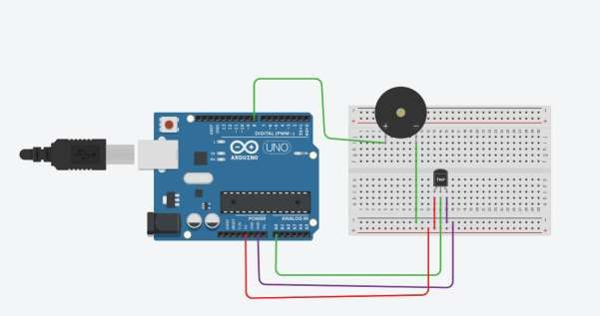

**Source Code –**

#define TEMP_PIN A0 // Pin where the TMP36 sensor is connected #define BUZZER_PIN 8 // Buzzer pin

const float TEMPERATURE_THRESHOLD = 23.0; // Temperature threshold in Celsius void setup() {

// Initialize the buzzer pin as an output pinMode(BUZZER_PIN, OUTPUT);

// Start the Serial Monitor for debugging Serial.begin(9600);

}

void loop() {

// Read the temperature from the TMP36 sensor int tempReading = analogRead(TEMP_PIN); float voltage = tempReading * (5.0 / 1023.0); float temperatureC = (voltage - 0.5) * 100.0;

// Print the temperature to the Serial Monitor Serial.print("Temperature: "); Serial.print(temperatureC);

Serial.println(" C");

// Check if the temperature exceeds the threshold

if (temperatureC > TEMPERATURE_THRESHOLD) {

// Turn on the buzzer digitalWrite(BUZZER_PIN, HIGH);

// Print an alert message to the Serial Monitor Serial.println("ALERT: Temperature is too high!");

} else {

// Turn off the buzzer digitalWrite(BUZZER_PIN, LOW);

}

// Wait for a short period before the next loop delay(500);

}

# Output –

Teamperature : 23.80 C Teamperature : 24.78 C

ALERT : Teamperature is too high !